Joel Atkinson
May 7, 2026
CSD440 Server-Side Scripting
Assignment 9.2

JoelIndex.php code:
<!-- Joel Atkinson, May 6, 2026. CSD440 Server-Side Scripting Assignment 9.2
The purpose of this program is to serve as the index page for the Module 9
assignment. It provides a navigation hub with links to all PHP files used in
this assignment, including the four files carried over from Module 8 (create,
populate, query, drop) and the three new files added in Module 9 (this index
page, a search/query page driven by user form input, and a form page that adds
a new record to the joel_mlb_teams table).
-->
<!DOCTYPE html>
<html lang="en">
<head>
<meta charset="UTF-8">
<meta name="viewport" content="width=device-width, initial-scale=1.0">
<title>Joel's MLB Index</title>
<style>
body {
font-family: Arial, sans-serif;
margin: 0;
}
.banner {
background-color: #663399;
padding: 20px 40px;
}
h1 {
color: #DAA520;
margin: 0;
text-align: center;
}
h2 {
color: #663399;
text-align: center;
margin-top: 30px;
}
.divider {
border: none;
border-top: 3px solid #DAA520;
margin: 0;
}
.content {
margin: 30px auto;
max-width: 800px;
padding: 0 40px;
}
.intro {
text-align: center;
color: #333;
line-height: 1.6;
margin: 20px 0;
}
.nav-section {
margin: 30px 0;
}
.nav-section h3 {
color: #663399;
border-bottom: 2px solid #DAA520;
padding-bottom: 8px;
}
.nav-list {
list-style: none;
padding: 0;
margin: 0;
}
.nav-list li {
margin: 10px 0;
}
.nav-list a {
display: block;
padding: 12px 20px;
background-color: #663399;
color: #DAA520;
text-decoration: none;
border-radius: 4px;
font-weight: bold;
transition: background-color 0.2s;
}
.nav-list a:hover {
background-color: #7a42b0;
}
.nav-list .description {
display: block;
font-weight: normal;
font-size: 0.9em;
color: #f2e5ff;
margin-top: 4px;
}
</style>
</head>
<body>
<div class="banner">
<h1>Joel's MLB Teams Database - Index</h1>
</div>
<hr class="divider">
<div class="content">
<p class="intro">
Welcome to the Module 9 index page for the joel_mlb_teams database.
Use the links below to navigate to each PHP program. The Module 9
programs are listed first, followed by the supporting Module 8
programs that build, load, and tear down the table.
</p>
<div class="nav-section">
<h3>Module 9 Programs</h3>
<ul class="nav-list">
<li>
<a href="JoelQuery.php">
JoelQuery.php
<span class="description">
Search the joel_mlb_teams table using a form. Filter by
league, division, team name, and minimum World Series wins.
</span>
</a>
</li>
<li>
<a href="JoelAddTeam.php">
JoelAddTeam.php
<span class="description">
Add a new team record to the joel_mlb_teams table using a
validated HTML form.
</span>
</a>
</li>
</ul>
</div>
<div class="nav-section">
<h3>Module 8 Programs</h3>
<ul class="nav-list">
<li>
<a href="JoelCreateTable.php">
JoelCreateTable.php
<span class="description">
Create the joel_mlb_teams table in the baseball_01 database.
</span>
</a>
</li>
<li>
<a href="JoelPopulateTable.php">
JoelPopulateTable.php
<span class="description">
Populate the joel_mlb_teams table with all 30 MLB teams.
</span>
</a>
</li>
<li>
<a href="JoelQueryTable.php">
JoelQueryTable.php
<span class="description">
Run a baseline SELECT query that returns every team sorted
by World Series wins.
</span>
</a>
</li>
<li>
<a href="JoelDropTable.php">
JoelDropTable.php
<span class="description">
Drop the joel_mlb_teams table from the baseball_01 database.
</span>
</a>
</li>
</ul>
</div>
</div>
</body>
</html>

Screenshot of output when navigating to localhost/JoelIndex.php:
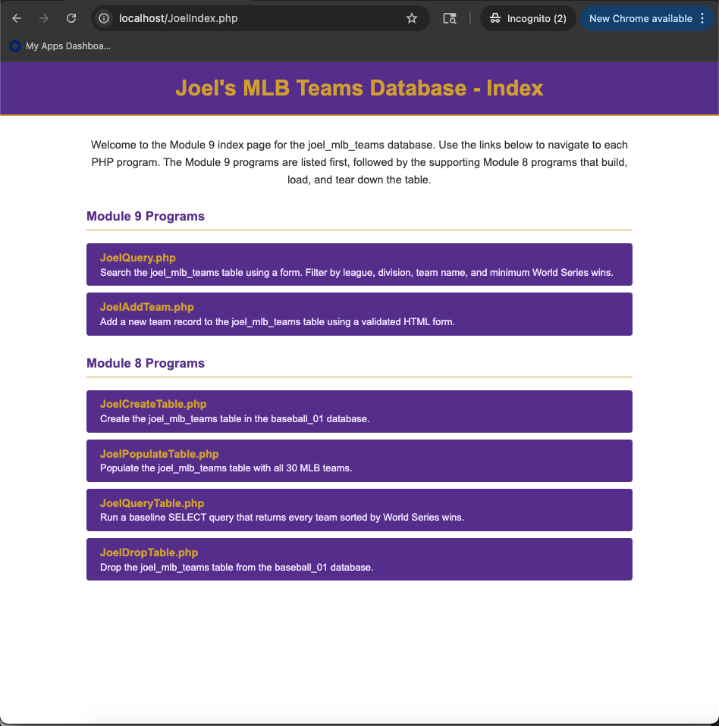

JoelAddTeam.php code:
<!-- Joel Atkinson, May 7, 2026. CSD440 Server-Side Scripting Assignment 9.2
The purpose of this program is to provide an HTML form that adds a new record
to the joel_mlb_teams table in the baseball_01 database. The form collects the
seven non-key fields (team name, city, league, division, founded year, World
Series wins, and mascot), validates them, and inserts the new row using a
MySQLi prepared statement. A success message is displayed when the insert
completes, or a list of validation errors when the input is invalid.
-->
<!DOCTYPE html>
<html lang="en">
<head>
<meta charset="UTF-8">
<meta name="viewport" content="width=device-width, initial-scale=1.0">
<title>Joel's MLB Add Team</title>
<style>
body {
font-family: Arial, sans-serif;
margin: 0;
}
.banner {
background-color: #663399;
padding: 20px 40px;
}
h1 {
color: #DAA520;
margin: 0;
text-align: center;
}
h2 {
color: #663399;
text-align: center;
margin-top: 30px;
}
.divider {
border: none;
border-top: 3px solid #DAA520;
margin: 0;
}
.content {
margin: 30px auto;
max-width: 700px;
padding: 0 40px;
}
.nav-bar {
text-align: center;
margin: 20px 0;
}
.nav-bar a {
color: #663399;
text-decoration: none;
font-weight: bold;
margin: 0 10px;
}
.nav-bar a:hover {
text-decoration: underline;
}
label {
display: block;
margin-top: 15px;
font-weight: bold;
color: #333;
}
input[type="text"],
input[type="number"],
select {
width: 100%;
padding: 8px;
margin-top: 5px;
border: 1px solid #666;
border-radius: 4px;
box-sizing: border-box;
font-family: Arial, sans-serif;
}
.submit-btn {
margin-top: 25px;
padding: 10px 30px;
background-color: #663399;
color: #DAA520;
border: none;
border-radius: 4px;
font-size: 16px;
cursor: pointer;
display: block;
width: 100%;
}
.submit-btn:hover {
background-color: #7a42b0;
}
.submit-btn.link {
text-align: center;
text-decoration: none;
display: block;
}
table {
border-collapse: collapse;
width: 100%;
margin: 20px 0;
}
th, td {
border: 1px solid #666;
padding: 10px 20px;
text-align: left;
}
th {
background-color: #663399;
color: #DAA520;
width: 35%;
}
tr:nth-child(even) {
background-color: #f2f2f2;
}
.error-box {
background-color: #ffe0e0;
border: 2px solid #cc0000;
color: #cc0000;
padding: 15px 20px;
border-radius: 4px;
margin: 20px 0;
}
.error-box ul {
margin: 10px 0 0 0;
padding-left: 20px;
}
.success-box {
background-color: #e0ffe0;
border: 2px solid #008800;
color: #008800;
padding: 15px 20px;
border-radius: 4px;
margin: 20px 0;
text-align: center;
font-weight: bold;
}
.info {
text-align: center;
color: black;
margin: 20px 40px 40px;
line-height: 1.8;
}
</style>
</head>
<body>
<div class="banner">
<h1>Add a Team to Joel's MLB Database</h1>
</div>
<hr class="divider">
<div class="content">
<div class="nav-bar">
<a href="JoelIndex.php">&larr; Back to Index</a>
</div>
<?php
// Decide whether to process a form submission or simply display the form.
if ($_SERVER["REQUEST_METHOD"] === "POST") {
// Collect and trim each submitted field, defaulting to an empty string if
// the field was not posted at all.
$teamName = trim($_POST["team_name"] ?? "");
$city = trim($_POST["city"] ?? "");
$league = trim($_POST["league"] ?? "");
$division = trim($_POST["division"] ?? "");
$founded = trim($_POST["founded_year"] ?? "");
$wsWins = trim($_POST["world_series_wins"] ?? "");
$mascot = trim($_POST["mascot"] ?? "");
// Collect any validation errors found in the input
$errors = array();
if (empty($teamName)) {
$errors[] = "Team Name is required.";
} elseif (strlen($teamName) > 75) {
$errors[] = "Team Name must be 75 characters or fewer.";
}
if (empty($city)) {
$errors[] = "City is required.";
} elseif (strlen($city) > 50) {
$errors[] = "City must be 50 characters or fewer.";
}
if ($league !== "AL" && $league !== "NL") {
$errors[] = "League must be AL or NL.";
}
if ($division !== "East" && $division !== "Central" && $division !== "West") {
$errors[] = "Division must be East, Central, or West.";
}
if ($founded === "") {
$errors[] = "Founded Year is required.";
} elseif (!ctype_digit($founded) || intval($founded) < 1800 || intval($founded) > 2100) {
$errors[] = "Founded Year must be a whole number between 1800 and 2100.";
}
if ($wsWins === "") {
$errors[] = "World Series Wins is required.";
} elseif (!ctype_digit($wsWins) || intval($wsWins) < 0 || intval($wsWins) > 50) {
$errors[] = "World Series Wins must be a whole number between 0 and 50.";
}
if (empty($mascot)) {
$errors[] = "Mascot is required.";
} elseif (strlen($mascot) > 50) {
$errors[] = "Mascot must be 50 characters or fewer.";
}
// If any validation errors were found, show them and stop.
if (!empty($errors)) {
echo '<div class="error-box">';
echo '<strong>Please fix the following errors:</strong>';
echo '<ul>';
foreach ($errors as $error) {
echo '<li>' . htmlspecialchars($error) . '</li>';
}
echo '</ul>';
echo '</div>';
echo '<a href="JoelAddTeam.php" class="submit-btn link">Go Back</a>';
} else {
// Input passed validation - open a database connection and insert.
$servername = "localhost";
$username = "student1";
$password = "pass";
$database = "baseball_01";
$conn = new mysqli($servername, $username, $password, $database);
if ($conn->connect_error) {
echo '<div class="error-box"><strong>Connection failed:</strong> '
. htmlspecialchars($conn->connect_error) . '</div>';
echo '<a href="JoelAddTeam.php" class="submit-btn link">Go Back</a>';
} else {
// Use a prepared statement so the user's input is bound safely
// and never concatenated directly into the SQL string.
$sql = "INSERT INTO joel_mlb_teams
(team_name, city, league, division,
founded_year, world_series_wins, mascot)
VALUES (?, ?, ?, ?, ?, ?, ?)";
$stmt = $conn->prepare($sql);
if ($stmt === false) {
echo '<div class="error-box"><strong>Prepare failed:</strong> '
. htmlspecialchars($conn->error) . '</div>';
echo '<a href="JoelAddTeam.php" class="submit-btn link">Go Back</a>';
} else {
$foundedInt = intval($founded);
$wsWinsInt = intval($wsWins);
// Bind types: four strings, two integers, one string.
$stmt->bind_param(
"ssssiis",
$teamName,
$city,
$league,
$division,
$foundedInt,
$wsWinsInt,
$mascot
);
if ($stmt->execute()) {
$newId = $stmt->insert_id;
echo '<div class="success-box">New team added successfully! Assigned team_id: '
. htmlspecialchars($newId) . '</div>';
// Echo the inserted record back so the user can confirm.
echo '<h2>Inserted Record</h2>';
echo '<table>';
echo '<tr><th>Field</th><th>Value</th></tr>';
echo '<tr><td>Team ID</td><td>' . htmlspecialchars($newId) . '</td></tr>';
echo '<tr><td>Team Name</td><td>' . htmlspecialchars($teamName) . '</td></tr>';
echo '<tr><td>City</td><td>' . htmlspecialchars($city) . '</td></tr>';
echo '<tr><td>League</td><td>' . htmlspecialchars($league) . '</td></tr>';
echo '<tr><td>Division</td><td>' . htmlspecialchars($division) . '</td></tr>';
echo '<tr><td>Founded</td><td>' . htmlspecialchars($foundedInt) . '</td></tr>';
echo '<tr><td>WS Wins</td><td>' . htmlspecialchars($wsWinsInt) . '</td></tr>';
echo '<tr><td>Mascot</td><td>' . htmlspecialchars($mascot) . '</td></tr>';
echo '</table>';
echo '<a href="JoelAddTeam.php" class="submit-btn link">Add Another Team</a>';
echo '<div class="nav-bar"><a href="JoelQuery.php">View teams in JoelQuery.php</a></div>';
} else {
echo '<div class="error-box"><strong>Insert failed:</strong> '
. htmlspecialchars($stmt->error) . '</div>';
echo '<a href="JoelAddTeam.php" class="submit-btn link">Go Back</a>';
}
$stmt->close();
}
$conn->close();
}
}
} else {
// No POST submission yet - show the empty form.
?>
<h2>Enter New Team Information</h2>
<form method="POST" action="JoelAddTeam.php">
<!-- Field 1: Team Name (text) -->
<label for="team_name">Team Name:</label>
<input type="text" id="team_name" name="team_name"
maxlength="75" placeholder="e.g. Seattle Mariners">
<!-- Field 2: City (text) -->
<label for="city">City:</label>
<input type="text" id="city" name="city"
maxlength="50" placeholder="e.g. Seattle">
<!-- Field 3: League (radio) -->
<label>League:</label>
<div style="margin-top: 5px;">
<input type="radio" id="leagueAL" name="league" value="AL">
<label for="leagueAL" style="display:inline; font-weight:normal;">American League (AL)</label>
&nbsp;&nbsp;
<input type="radio" id="leagueNL" name="league" value="NL">
<label for="leagueNL" style="display:inline; font-weight:normal;">National League (NL)</label>
</div>
<!-- Field 4: Division (select dropdown) -->
<label for="division">Division:</label>
<select id="division" name="division">
<option value="">-- Select a Division --</option>
<option value="East">East</option>
<option value="Central">Central</option>
<option value="West">West</option>
</select>
<!-- Field 5: Founded Year (number) -->
<label for="founded_year">Founded Year:</label>
<input type="number" id="founded_year" name="founded_year"
min="1800" max="2100" placeholder="e.g. 1977">
<!-- Field 6: World Series Wins (number) -->
<label for="world_series_wins">World Series Wins:</label>
<input type="number" id="world_series_wins" name="world_series_wins"
min="0" max="50" placeholder="e.g. 0">
<!-- Field 7: Mascot (text) -->
<label for="mascot">Mascot:</label>
<input type="text" id="mascot" name="mascot"
maxlength="50" placeholder="e.g. Mariner Moose">
<button type="submit" class="submit-btn">Add Team</button>
</form>
<?php } ?>
</div>
<p class="info">
<strong>Author:</strong> Joel Atkinson<br>
<strong>Course:</strong> CSD 440 - Server-Side Scripting<br>
<strong>Assignment:</strong> 9.2 - Form Page<br>
<strong>Description:</strong> This program presents an HTML form that adds
a new record to the joel_mlb_teams table. It collects seven fields using
text, radio, select, and number input types, validates each field, and
inserts the row using a MySQLi prepared statement. A formatted summary of
the inserted record is displayed on success, while validation errors are
listed when the input is invalid.
</p>
</body>
</html>

Screenshot when navigating to localhost/JoelAddTeam.php:
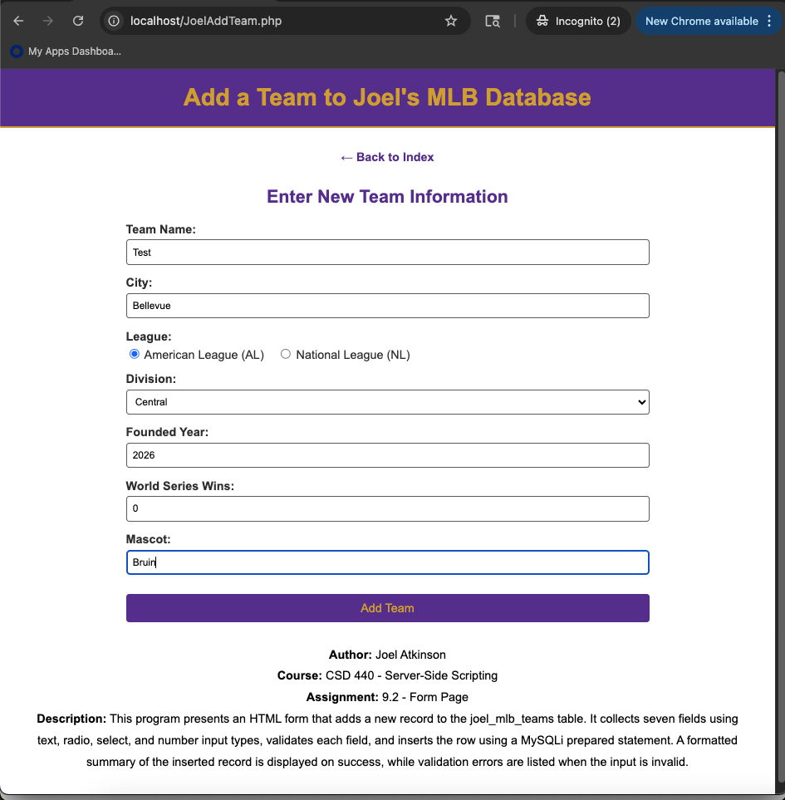
Screenshot after adding team to database:
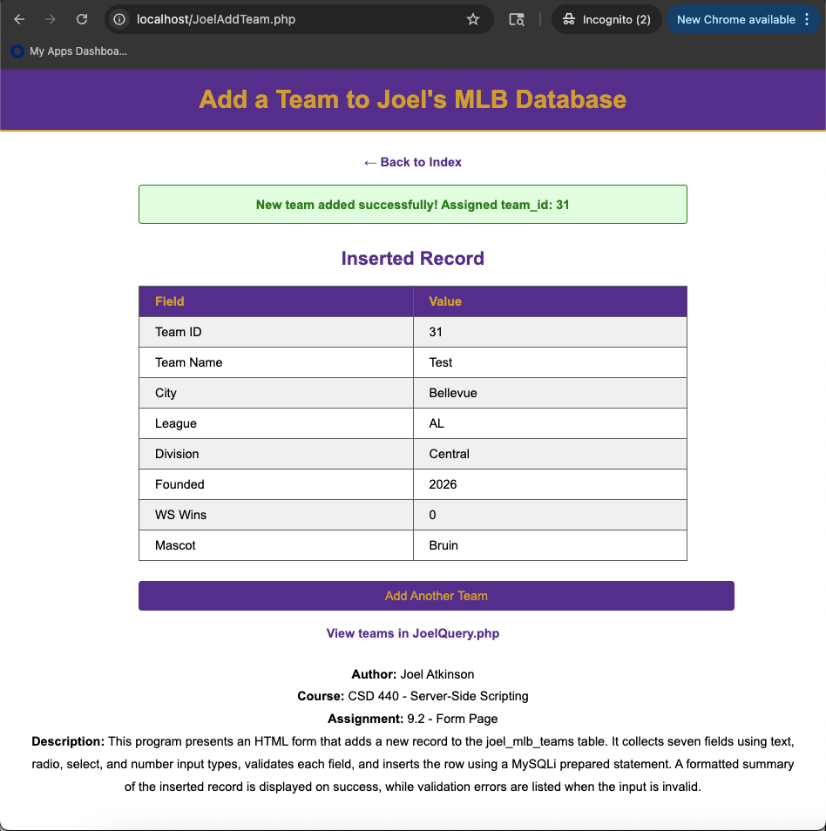
Screenshot from within database in XAMPP showing it connected and added team:
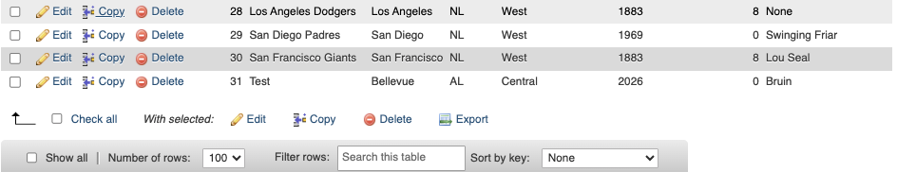

JoelQuery.php code:
<!-- Joel Atkinson, May 7, 2026. CSD440 Server-Side Scripting Assignment 9.2
The purpose of this program is to query the joel_mlb_teams table based on
user-supplied form input. The user can filter results by league, division,
a partial team name match, and a minimum number of World Series wins. The
program builds a SELECT statement using prepared statements, binds the user
input safely, and displays the matching rows in a formatted HTML table.
-->
<!DOCTYPE html>
<html lang="en">
<head>
<meta charset="UTF-8">
<meta name="viewport" content="width=device-width, initial-scale=1.0">
<title>Joel's MLB Query</title>
<style>
body {
font-family: Arial, sans-serif;
margin: 0;
}
.banner {
background-color: #663399;
padding: 20px 40px;
}
h1 {
color: #DAA520;
margin: 0;
text-align: center;
}
h2 {
color: #663399;
text-align: center;
margin-top: 30px;
}
.divider {
border: none;
border-top: 3px solid #DAA520;
margin: 0;
}
.content {
margin: 30px auto;
max-width: 1000px;
padding: 0 40px;
}
.nav-bar {
text-align: center;
margin: 20px 0;
}
.nav-bar a {
color: #663399;
text-decoration: none;
font-weight: bold;
margin: 0 10px;
}
.nav-bar a:hover {
text-decoration: underline;
}
label {
display: block;
margin-top: 15px;
font-weight: bold;
color: #333;
}
input[type="text"],
input[type="number"],
select {
width: 100%;
padding: 8px;
margin-top: 5px;
border: 1px solid #666;
border-radius: 4px;
box-sizing: border-box;
font-family: Arial, sans-serif;
}
.submit-btn {
margin-top: 25px;
padding: 10px 30px;
background-color: #663399;
color: #DAA520;
border: none;
border-radius: 4px;
font-size: 16px;
cursor: pointer;
display: block;
width: 100%;
}
.submit-btn:hover {
background-color: #7a42b0;
}
.form-row {
display: flex;
gap: 20px;
}
.form-row > div {
flex: 1;
}
table {
border-collapse: collapse;
width: 100%;
margin: 20px 0;
}
th, td {
border: 1px solid #666;
padding: 8px 12px;
text-align: left;
}
th {
background-color: #663399;
color: #DAA520;
}
tr:nth-child(even) {
background-color: #f2f2f2;
}
.success-box {
background-color: #e0ffe0;
border: 2px solid #008800;
color: #008800;
padding: 15px 20px;
border-radius: 4px;
margin: 20px 0;
text-align: center;
font-weight: bold;
}
.error-box {
background-color: #ffe0e0;
border: 2px solid #cc0000;
color: #cc0000;
padding: 15px 20px;
border-radius: 4px;
margin: 20px 0;
}
.info-box {
background-color: #fff8e0;
border: 2px solid #DAA520;
color: #5a4500;
padding: 15px 20px;
border-radius: 4px;
margin: 20px 0;
text-align: center;
}
.info {
text-align: center;
color: black;
margin: 20px 40px 40px;
line-height: 1.8;
}
</style>
</head>
<body>
<div class="banner">
<h1>Query Joel's MLB Teams</h1>
</div>
<hr class="divider">
<div class="content">
<div class="nav-bar">
<a href="JoelIndex.php">&larr; Back to Index</a>
</div>
<h2>Search the joel_mlb_teams Table</h2>
<?php
// Capture the submitted values so the SQL query below can use them.
// The form itself is rendered empty on every load so the user always
// sees a blank search form.
$searchTeam = isset($_GET["team_name"]) ? trim($_GET["team_name"]) : "";
$searchLeague = isset($_GET["league"]) ? trim($_GET["league"]) : "";
$searchDivision = isset($_GET["division"]) ? trim($_GET["division"]) : "";
$searchMinWins = isset($_GET["min_wins"]) ? trim($_GET["min_wins"]) : "";
?>
<form method="GET" action="JoelQuery.php" autocomplete="off">
<label for="team_name">Team Name Contains:</label>
<input type="text" id="team_name" name="team_name"
placeholder="e.g. Sox, Yankees, Cardinals">
<div class="form-row">
<div>
<label for="league">League:</label>
<select id="league" name="league">
<option value="" selected>-- Any League --</option>
<option value="AL">American League (AL)</option>
<option value="NL">National League (NL)</option>
</select>
</div>
<div>
<label for="division">Division:</label>
<select id="division" name="division">
<option value="" selected>-- Any Division --</option>
<option value="East">East</option>
<option value="Central">Central</option>
<option value="West">West</option>
</select>
</div>
</div>
<label for="min_wins">Minimum World Series Wins:</label>
<input type="number" id="min_wins" name="min_wins" min="0" max="50"
placeholder="Leave blank for any">
<button type="submit" class="submit-btn">Search Teams</button>
</form>
<?php
// Only run a query when the user has actually submitted the form. We use
// the presence of the form's submit method (GET) plus at least one of the
// search fields being set. Checking $_SERVER["QUERY_STRING"] keeps the
// results from running on the very first page load.
if (!empty($_SERVER["QUERY_STRING"])) {
// Database connection variables for the baseball_01 MySQL database
$servername = "localhost";
$username = "student1";
$password = "pass";
$database = "baseball_01";
// Open a new connection to the MySQL server using MySQLi
$conn = new mysqli($servername, $username, $password, $database);
if ($conn->connect_error) {
echo '<div class="error-box"><strong>Connection failed:</strong> '
. htmlspecialchars($conn->connect_error) . '</div>';
} else {
// Build the WHERE clause dynamically based on which fields the user
// filled in. Each filter adds a placeholder to the SQL and a value
// to the bind list, which keeps the query safe from SQL injection.
$whereParts = array();
$bindTypes = "";
$bindValues = array();
if ($searchTeam !== "") {
$whereParts[] = "team_name LIKE ?";
$bindTypes .= "s";
$bindValues[] = "%" . $searchTeam . "%";
}
if ($searchLeague !== "") {
$whereParts[] = "league = ?";
$bindTypes .= "s";
$bindValues[] = $searchLeague;
}
if ($searchDivision !== "") {
$whereParts[] = "division = ?";
$bindTypes .= "s";
$bindValues[] = $searchDivision;
}
if ($searchMinWins !== "" && is_numeric($searchMinWins)) {
$whereParts[] = "world_series_wins >= ?";
$bindTypes .= "i";
$bindValues[] = intval($searchMinWins);
}
// Assemble the final SQL. If no filters were provided, the WHERE
// clause is omitted and the query returns every row.
$sql = "SELECT team_id, team_name, city, league, division,
founded_year, world_series_wins, mascot
FROM joel_mlb_teams";
if (!empty($whereParts)) {
$sql .= " WHERE " . implode(" AND ", $whereParts);
}
$sql .= " ORDER BY world_series_wins DESC, team_name ASC";
// Use a prepared statement so the user's input is bound safely.
$stmt = $conn->prepare($sql);
if ($stmt === false) {
echo '<div class="error-box"><strong>Prepare failed:</strong> '
. htmlspecialchars($conn->error) . '</div>';
} else {
if (!empty($bindValues)) {
$stmt->bind_param($bindTypes, ...$bindValues);
}
$stmt->execute();
$result = $stmt->get_result();
if ($result === false) {
echo '<div class="error-box"><strong>Query failed:</strong> '
. htmlspecialchars($stmt->error) . '</div>';
} elseif ($result->num_rows === 0) {
echo '<div class="info-box">No teams matched your search criteria. '
. 'Try removing a filter or broadening your search.</div>';
} else {
echo '<div class="success-box">'
. $result->num_rows . ' team(s) matched your search.</div>';
echo '<table>';
echo '<tr>';
echo '<th>ID</th>';
echo '<th>Team</th>';
echo '<th>City</th>';
echo '<th>League</th>';
echo '<th>Division</th>';
echo '<th>Founded</th>';
echo '<th>WS Wins</th>';
echo '<th>Mascot</th>';
echo '</tr>';
while ($row = $result->fetch_assoc()) {
echo '<tr>';
echo '<td>' . htmlspecialchars($row["team_id"]) . '</td>';
echo '<td>' . htmlspecialchars($row["team_name"]) . '</td>';
echo '<td>' . htmlspecialchars($row["city"]) . '</td>';
echo '<td>' . htmlspecialchars($row["league"]) . '</td>';
echo '<td>' . htmlspecialchars($row["division"]) . '</td>';
echo '<td>' . htmlspecialchars($row["founded_year"]) . '</td>';
echo '<td>' . htmlspecialchars($row["world_series_wins"]) . '</td>';
echo '<td>' . htmlspecialchars($row["mascot"]) . '</td>';
echo '</tr>';
}
echo '</table>';
$result->free();
}
$stmt->close();
}
$conn->close();
}
}
?>
</div>
<p class="info">
<strong>Author:</strong> Joel Atkinson<br>
<strong>Course:</strong> CSD 440 - Server-Side Scripting<br>
<strong>Assignment:</strong> 9.2 - Query Page<br>
<strong>Description:</strong> This program lets the user search the
joel_mlb_teams table by team name (partial match), league, division, and
minimum World Series wins. It uses a MySQLi prepared statement so user
input is bound safely, and displays the matching rows in a formatted HTML
table sorted by World Series wins.
</p>
</body>

Screenshot of output when going to localhost/JoelQuery.php:
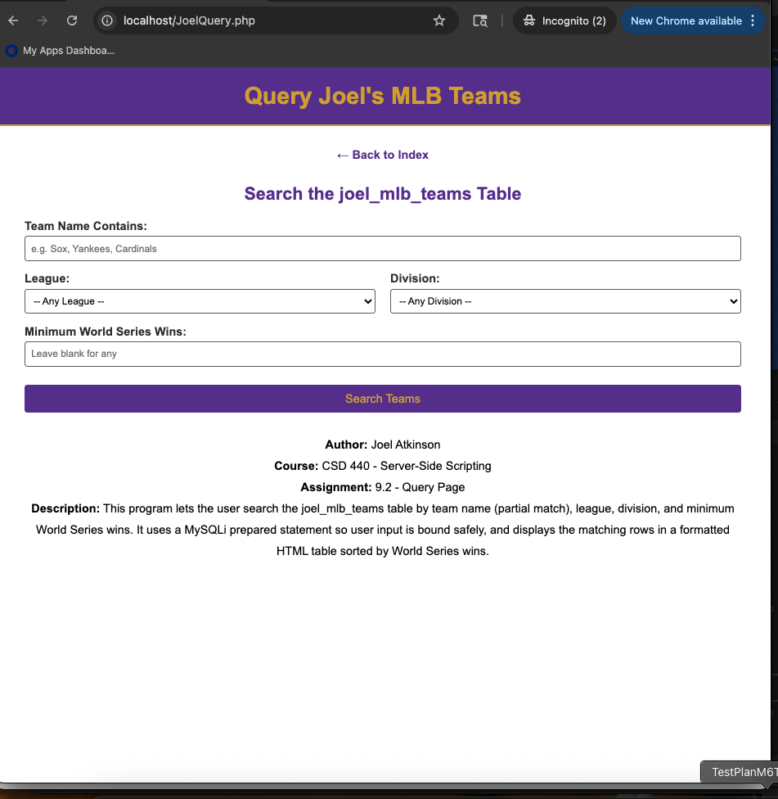
Screenshot of output when using search feature to prove it queries and works correctly. I typed in “Arizona” into “Team Name Contains” and received this output:
